**The Geography of Radio**

Alternative Title: *Real-time Web-Radio Audio Sampling, Processing, and Logging as a Proxy for Spatio-temporal Popular Music Trends*

Author: Michael Felzan

Date: December 20th 2021

**Project Repository:**<https://github.com/fezfelzan/Geography-of-Radio.git>

**Abstract**

Most of the existing literature related to use of radio as a socio-geographic data source is concerned with documenting its virtual absence (Murthy 2008; Pinkerton and Dodds 2009; Gallagher and Prior 2014; Pompeii 2015). Though there is widespread consensus that radio-based phonography could be an invaluable frontier for conducting qualitative geographic research (Pompeii 2015; Gallagher and Prior 2014), there is seemingly no existing work which capitalizes on the ability to move towards actualizing radio ethnographies through programmatic sampling and transcription of the now ubiquitous web-streaming alternatives for FM radio stations. This project presents an extract-load-transfer (ETL) methodology for iteratively sampling radio station streams in order to generate a database which details spatio-temporal music trends throughout the US. We use a Python-based approach which iteratively samples audio clips from a collection of online radio streams, identifies the songs playing in those clips using a music recognition API, retrieves detailed genre information associated with those songs via a music database API, retrieves technical details about each radio tower associated with the URL stream (ERP, HAAT, distance given a specific field strength (dBu), geographic coordinates), and organizes all of this data into spreadsheets which are interoperable within GIS software like ArcGIS Pro. A spatial analysis of a dataset generated from our ETL is shown here, including a statistical surface (kriging) map showing the normalized prevalence of music genres linked to the date/time at which they are broadcasted. We postulate that broadcast signal reach (distance from radio tower yielding 60 dBμ, the contour line at which most urban stations start to lose reception (Wanniarachchi and Abayaratne 2007)) echoing Pinkerton and Dodds’ (2009) assertion that “the geographies of broadcasting and listening [are] highly contingent.” Working under this assumption, we present a novel case study which addresses the intersection of geography and radio, via automated, parallized real-time audio sampling of FM stations (those which have streamable web broadcasts), and associated mock-analysis of spatiotemporal cultural trends across the US. This report concludes with a discussion on the implications, drawbacks, and opportunities for future work associated with our study.

**Introduction**

Personal computers and “smart devices” are becoming completely integrated in our everyday lives, serving as primary mediums through which we communicate, consume media, and organize travel routes. In part of the ongoing COVID-19 pandemic, this is only becoming more prevalent. It is therefore no surprise that a large majority of FM radio stations in the US have already set up web-access to their live broadcasts. A team of programmers from Amsterdam capitalized on the now widespread digital availability of radio streams through designing the website “Radio Garden,” which allows users to tune into thousands of live radio streams by clicking points on a world map corresponding to the approximate locations of those station’s radio towers. The ability to remotely access FM radio broadcasts—which we argue are hyper-local cultural barometers—offers vast opportunities associated with programmatic data-scraping and the acquisition of socio-geographic data.

Radio, as it relates to the field of geography, is virtually untapped territory. Wikle et al. (2010) in their report on the ‘new geography’ of religious radio state that the existing “geographic research focused on radio is limited in scope.” Pompeii (2015) claims that in his “review of literature regarding ethnographic and qualitative methods” that he found “only one example (Barker and Weller 2003) of the radio as a research tool,” with more recent articles only suggesting the “potential for more phonographic methods within qualitative geographic inquiry.” Pinkerton and Dodds (2009) argue the “neglect of radio” in existing geographic literature is “short-sighted,” while Murthy (2008) laments the “high level of invisibility” surrounding digital ethnographic methods in social research, while Gallagher and Prior (2014) suggest that radio in its relation to geographical inquiry “deserves more attention” and “as much attention as any other approach.” And although Pompeii (2015) notes the existence of “very few examples” where studies “[use] the internet or other media as a tool to accompany the ethnographic research of a place,” to our knowledge, no prior studies have utilized programmatic, online radio-sampling as a geographic and ethnographic method.

This report assesses the viability of an ETL methodology which programmatically samples audio from a variety of radio stations in the US, in order to compile a database which details the types of music played by specific radio stations, organized by airplay date/time. We assume here that the content aired by a radio station may be associated with the real-time cultural trends of the locations which receive that station’s broadcast, as radio listeners are not passive but rather contributors to the content which receive airplay (Pinkerton and Dodds 2009). The intent of this project is to assess how feasibility web-radio audio-sampling may provide a representative snapshot of how localized cultural trends change through time.

**Methods**

Audio Sampling and API Routing

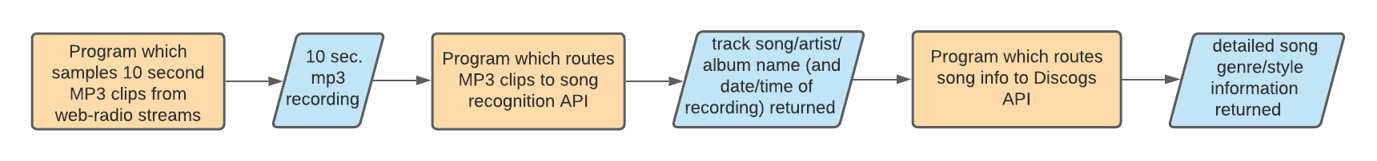

***Figure 1.*** *Flow diagram showing the series of API calls/routings used in our study to return song style information from audio recordings of radio streams.*

The first portion of our ETL methodology involves capturing audio segments from the web-streams of FM radio stations. We utilize the open-source “FFmpeg” library within a Python environment to iteratively sample 10-second, 128 Kbps MP3 clips from each stream URL on our list of station streams. This program includes the functionality to save each of these clips as reference files in an organized database. After the audio clip has been sampled and saved to local disk storage, the clip is then routed to a song recognition API which returns the name of the song (and associated artist/album), if any, being played within the clip. We are specifically focused on music in this study, though one could follow a similar methodology to use speech-to-text processing on talk-radio. We utilize ACRCloud’s API for music recognition. If the ACRCloud API is able to recognize the song playing in the audio clip and successfully returns the name of the song/artist/album, this information is then packaged into another API request – this time to a music database API. We utilize the crowdsourced Discogs API to return highly detailed genre/style information about each song identified by the song recognition API. Discogs is one of the most comprehensive existing online music databases in the public domain (Bogdanov and Serra 2017) and hosts particularly detailed (sub)genre information associated with each song. If the Discogs API returns valid genre information about the song name sent in the request header, our program then logs the name of the MP3 reference clip (which contains the date and time of sampling in its naming convention), the song, artist, album, and genre information in a dedicated “song-play” text file. Both the song recognition API and the music database API must yield a valid result in order for an entry to be written in the text file. A folder repository and corresponding song-play text file is created for each individual station.

Data Preparation

To give our temporal song-play-by-station data a spatial component, we generated a point-class shapefile within ArcGIS Pro using the geographic coordinates of each FM radio tower corresponding to the station web-streams we sampled. Due to monetary and computational limitations, our sample set comprised the web-streams of 47 radio stations in the state of Washington. We used all of the Washington radio station streams hosted on Radio Garden’s website that we could confirm had powered FM tower counterparts, throwing out any streams/stations with seemingly broken stream URLs (full list of stations used available in GitHub repository). Although each station sampled in this study is web-accessible, we assume that any physical radio tower that’s remained in operation must have real-world demand/ influence, and therefore the content aired by those stations is in some way representative of the surrounding community’s interests. Taking this assumption further, we postulate that the broadcast reach of a station (or the geographic areas which receive ‘fair’ signal from a given station) may further constrain the geography of cultural interests communicated through a station’s content decisions. We used the Radio-Locator API to obtain information about each of our sample station’s precise tower location and broadcast reach. The Radio-Locator database offers information on most FM radio towers’ geographic coordinates (in degrees-minutes-seconds), antenna height above average terrain (HAAT), and effective radiated power (ERP). We borrowed JavaScript from the FCC’s web-calculator for “FM and TV Propagation Curves” for our ETL, allowing “distance from a radio tower, given a field strength (in dBu)” to be iteratively calculated for all sample stations via each station tower’s HAAT and ERP. A field strength of 60dBu is considered local coverage (Wanniarachchi and Abayaratne 2007), so the distance from each tower yielding a field strength of 60dBu was calculated for each station. All relevant radio tower statistics were linked to their associated station’s point feature in our ‘stations’ point-class shapefile. As the song-play logs for each station are organized by callsign name (eg. “KEXP”), this data was easily joined with our point features. Figure 4 shows an example of how one of these song-play logs are organized.

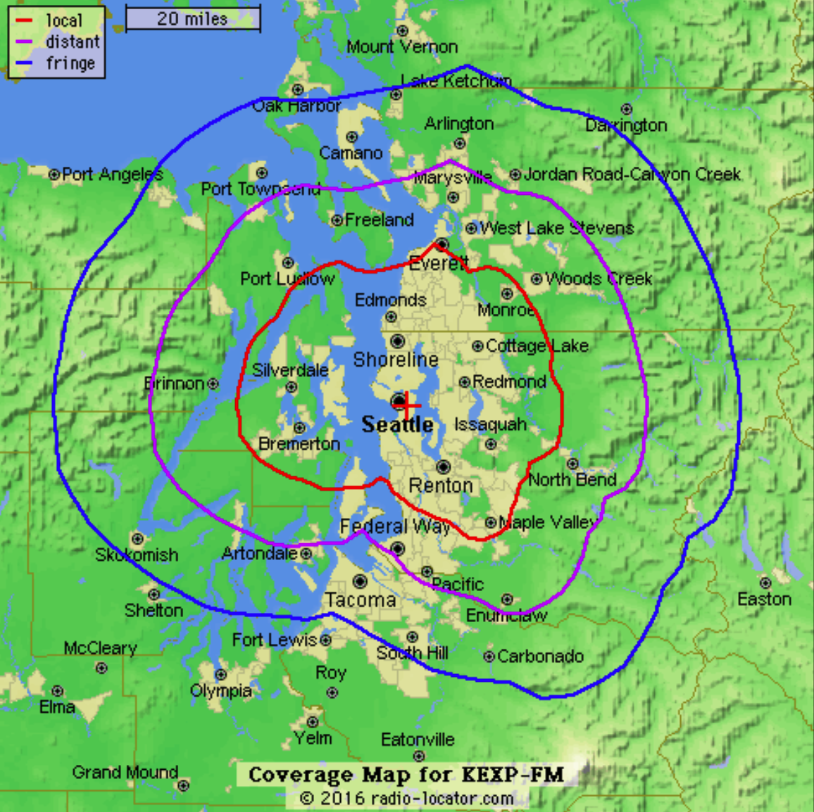

***Figure 2.*** *Example broadcast coverage map for the radio station ‘KEXP,’ provided by radio-locator.com. Here the ‘local’ coverage buffer represents the distance from the radio tower which would yield a field strength of 60 dBu.*

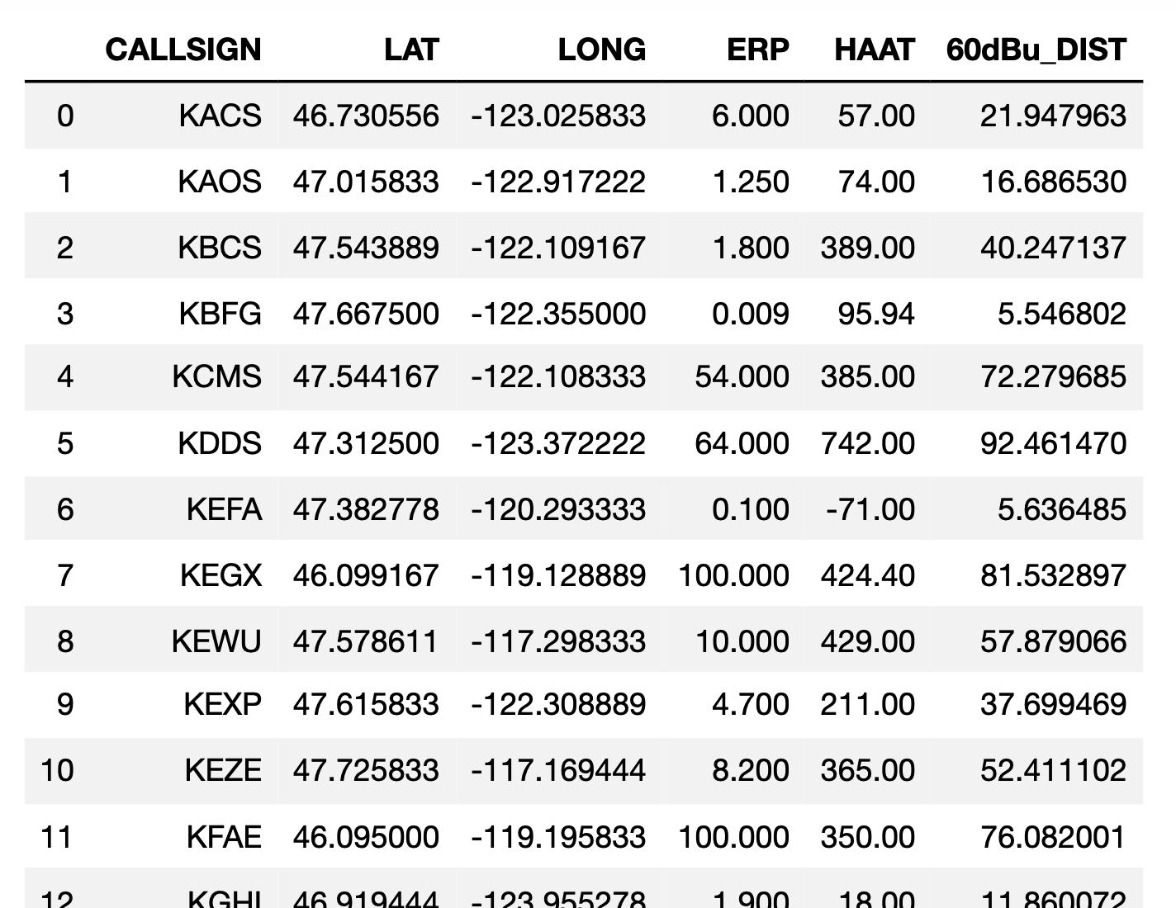

***Figure 3.*** *Each station’s radio tower statistics are organized in a table with the following attributes. A point-class shapefile is generated in ArcGIS Pro using the latitude and longitude information, and a ‘local coverage’ buffer may be generated from the ‘60 dBu Distance’ value.*

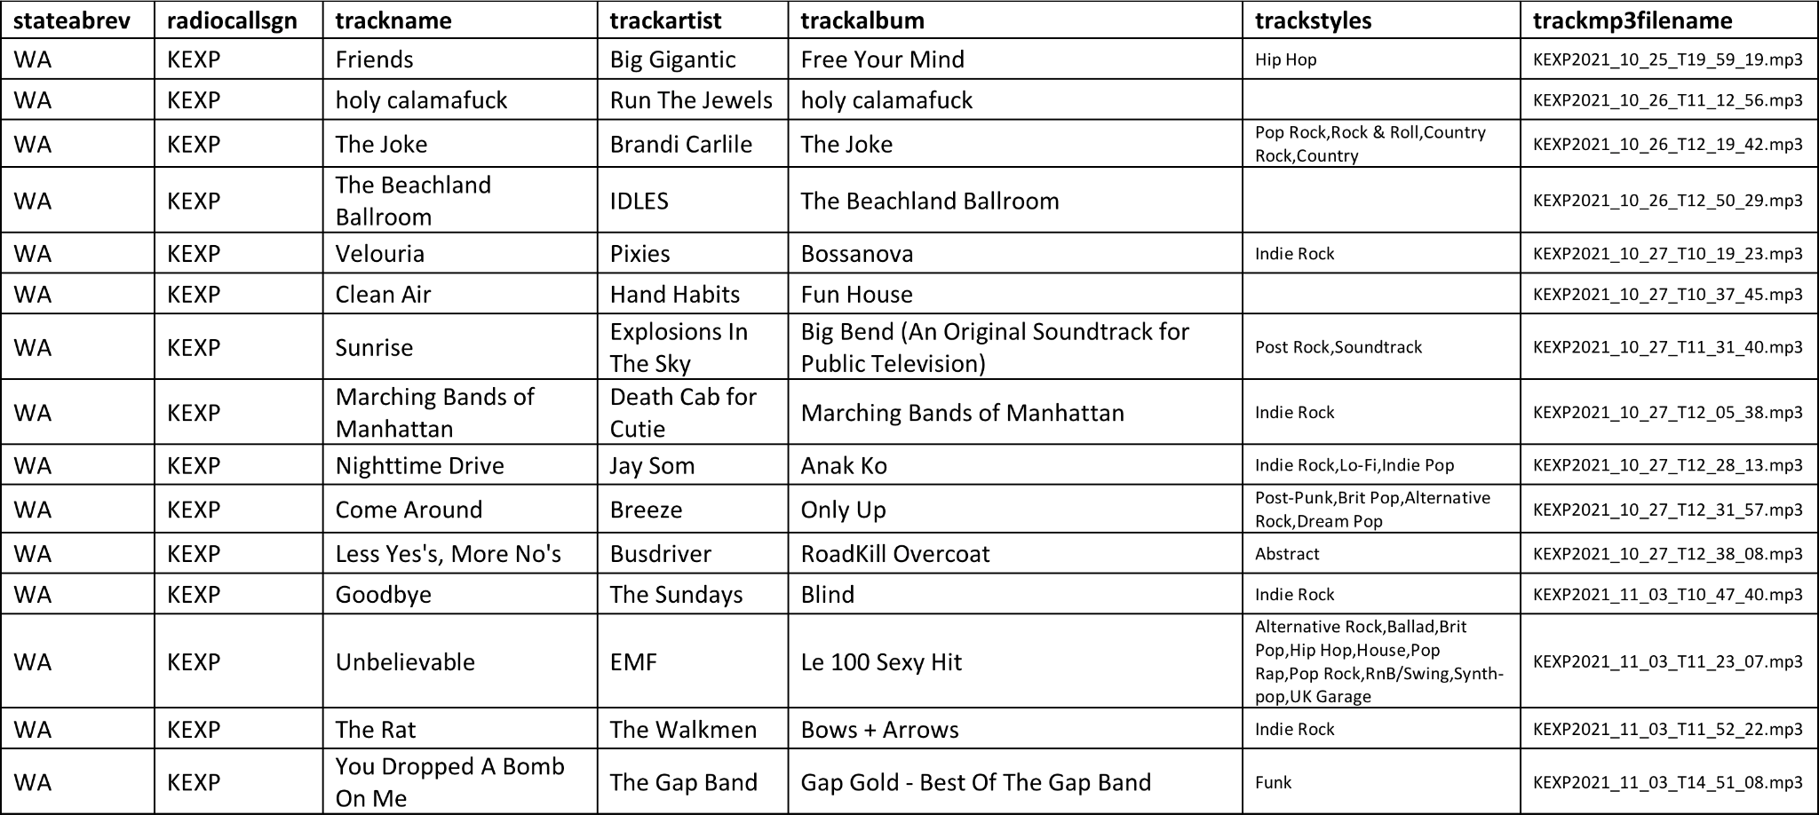

***Figure 4.*** *An example of how each station’s “track play log” is organized. Each station has their own individual file for documenting the songs (and their associated information) played by that station. These tables are automatically populated by our program, only if both the ACRCloud API successfully returns a song name and the Discogs API returns genre/style tags (though sometimes blank tags are returned). The naming convention for the “trackmp3filename” is formatted as “[station callsign][capture year][capture month][day][hour][minute][second],” effectively providing the date/time of each recording, and ultimately allowing for temporal analysis.*

Spatial Analysis

In order to analyze the variation in genres of music played by radio stations across a geographic extent, broader categories for “genre” must first be defined. An example would be grouping the subgenres of “classic rock,” “hard rock,” and “southern rock” under an overarching “Rock” category, or creating a similar umbrella category for religious music. Of course, it may make most sense to create genre category definitions after both a research question has been established and the various unique genres that appear in a dataset are known. The geographic prevalence of electronic music in the state of Washington, based on a sample set of 47 FM stations which were sampled over the span of a week, was used as an example case study to assess the viability of our proposed methodology. We first defined an “electronic music” category based on the list of unique genres that appeared in our dataset, and then ran a program which tallied the amount of songs played by each station containing genre tags falling within our category (the list of genres used for our definition is available in our GitHub repository). Dividing the number of electronic music-related songs by the total number of songs played by each station yields a proportion of electronic music played by each station. Because this proportion value is effectively normalized between stations, we may use the variation of these station proportions across geographic space to produce a spatial analysis. We use the Gaussian spatial interpolation method Kriging in this study to produce an example statistical surface, showing the variation in prevalence of radio-played electronic music across the state of Washington.

**Results**

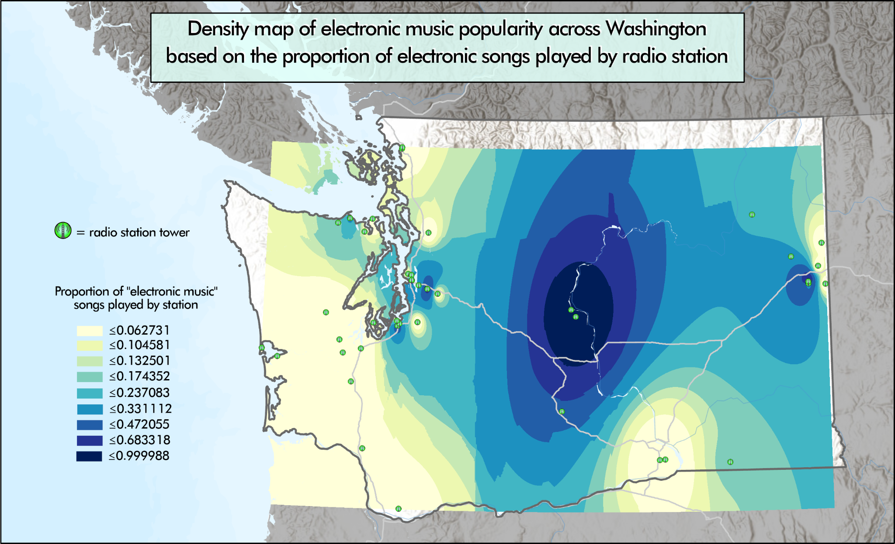

***Figure 5.*** *A sample spatial analysis (statistical surface) produced from song-play information derived from sampling the web-stream counterparts of FM radio stations. Kriging was used here to to create a density map showing the proportion of electronic music songs (out of total number of recorded songs) played by each sampled radio station.*

This study presents a working Python- and ArcGIS Pro-based methodology for real-time sampling and tabulating the songs (and their associated information) played on air from radio stations across the world. We’ve successfully created an ETL process which takes a list of radio stations and their web-stream URL addresses as input data, and through iteratively sampling the audio from each URL address for an extended period of time, outputs a spatial dataset containing the attributes needed for interpolation analysis such as kriging.

The actual cultural geographic analysis carried out in this study is minimal and mainly a vehicle for assessing the viability of our ETL methodology. A reason for deemphasizing the assessment of geographic trends in music preference was the scantiness of our sampled data. We believe the production of meaningful results requires hundreds of radio station streams to be sampled *simultaneously*, through the use of multiprocessing/threading libraries. Sampling in this manner would create a more concrete temporal linkage between the trends observed in various locales, and how those trends propagate over space and time. At present, more work is needed to properly parallelize our code (although a dedicated Python library exists for FFmpeg—the program used for used sampling in this study—the program still operates at the command-line level, which causes synchronization problems when using Python to dole out threaded processes). Additionally, although data was collected to use broadcast reach (distance at which field strength is 60dBu) to further constrain the geographic influence of radio stations, this data was not incorporated into our sample analysis. The implications and limitations of these results are further discussed in the following section.

**Discussion & Conclusion**

The development of the extract-transfer-load (ETL) system presented in this study is motivated by the belief that radio, a domain currently untapped by existing geographic literature, has increasing potential to be ‘tapped’ through the prevalence of web-streaming alternatives offered by real-world FM stations, and more importantly, that the ability to real-time ‘data-mine’ the radio offers invaluable implications to the field of cultural geography, given the hyper-local nature of radio station towers and the communities that uphold them. This study only focuses on music and establishing a methodology for analyzing the spatio-temporal variation in music trends. However, the same methodology presented here could be appropriated for a study involving talk radio, through substituting a music recognition API for speech-to-text software. The implications of this kind of study may be even more vast, allowing for the analysis of how key phrases and news stories propagate through space and time through a network of radio-tower nodes.

The value we argue radio possesses as a geographic data source is contingent on a set of assumptions which we acknowledge are disputable. The first of which being that the web-streams of FM stations present any sort of ground-level view of the culture and societal interests of the locations that receive those real-world FM broadcasts. This is based on another assumption, that the persistence of an operational physical radio tower reflects an ongoing relationship of shared interests with the local community. With the expansion of web-accessible radio streams, it may be conversely argued that these stations are really in conversation with a more national or global community, broadcasting content which appeals more to populations outside the breadth of their FM transmission in order to secure outside funding. To truly assess this, honest and accurate metricsdetailing the average proportion of web-listeners versus those tuning in with antennas would need to be known for each station, which is virtually impossible. Additionally, one could argue the sources of funding for each radio station must be known to determine whether a station’s broadcasted content is a direct response to the greater community’s interests, or is rather what a handful of influential donors want on air. iHeartRadio (FKA Clear Channel) is well-known for their online radio services, though the company is also the largest owner of radio stations in the United States, owning around 860 full-power AM and FM stations (Albarran and Rhoades 2020). None of the 5,600 US radio stations streams (sourced from Radio Garden) we used in our study were iHeartRadio stations, primarily because the company utilizes a convoluted privacy measure of streaming audio in 10 second chunks, generating a new unique stream URL for every 10 second segment. However, the strong, diffuse influence of capitalist actors on radio decisions cannot be ignored.

Even if the assumptions in this study are accepted at face value, there exist limitations with the radio data-mining and associated spatial analysis methods we’re advancing. The ACRCloud music recognition API we used, at the consumer level, has a fee of $1.7 per valid 1,000 requests. If a larger scale study was proposed using the same API, sampling thousands of US radio stations streams every 3 minutes, the cost for even one day’s worth of data would similarly be in the thousands. Additionally, it is arguably vital to produce reference data (MP3s) corresponding to the song/genre names logged and tabulated in order to validate the truth of the reported data. Pompeii (2015) implies that “triangulation,” the process of validating information by two or more sources, is needed to properly validate qualitative radio data. Saving 128 Kbps reference MP3 files for all 5,000 radio stations sampled at 3-minute intervals would require data storage at the terabyte level per day. And of course, one would need a designated supercomputer to run a software similar to ours, uninterrupted, for an extended period of time.

It could very well be the case that the theoretical assumptions and physical costs required for this type of study are responsible for radio’s virtual absence in the existing modern geographic literature. However, there are ways the limitations associated with up-scaling our methodology could be reduced. The projected costs of our project could be cut through using an open-source or custom song recognition software (or obtaining a partnership with an existing API provider). Additionally, although it may jeopardize the ability to “prove” the validity of each station’s song-play log, all (or a large portion of) the reference MP3 files could be deleted immediately after the API requests are returned.

All existing sources of GIS data related to the social sciences are not without their own sets of limitations and assumptions. Despite the caveats with utilizing radio as a geographic data source, many (Murthy 2008; Pinkerton and Dodds 2009; Gallagher and Prior 2014; Pompeii 2015) agree that the prior neglect of radio in geographic inquiries is a sorely missed opportunity. Due to the intrinsically hyper-local nature of radio stations and their potential to represent marginalized voices (Murthy 2008), the use of radio in qualitative geographic research could present information unattainable by any other existing method (Pompeii 2015). We believe the work presented in this study is a novel nucleation point for materializing radio-based geographic research.

References

Albarran, A. B., & Rhoades, G. R. (2020). CBS-Entercom and the Reverse Morris Trust: Implications for

the Radio Industry and Future Media Mergers. *Journal of Radio & Audio Media*, 1-12.

Barker, J., & Weller, S. (2003). Geography of methodological issues in research with children. *Qualitative*

*research*, *3*(2), 207-227.

Bogdanov, D., & Serra, X. (2017). Quantifying music tends and facts using editorial metadata from the

Discogs database. In *Hu X, Cunningham SJ, Turnbull D, Duan Z. ISMIR 2017 Proceedings of the 18th International Society for Music Information Retrieval Conference; 2017 Oct 23-27; Suzhou, China.[Suzhou]: ISMIR; 2017. p. 89-95.*. International Society for Music Information Retrieval (ISMIR).

Gallagher, M., & Prior, J. (2014). Sonic geographies: Exploring phonographic methods. *Progress in*

*human geography*, *38*(2), 267-284.

Murthy, D. (2008). Digital ethnography: An examination of the use of new technologies for social

research. *Sociology*, *42*(5), 837-855.

Pinkerton, A., & Dodds, K. (2009). Radio geopolitics: broadcasting, listening and the struggle for acoustic

spaces. *Progress in Human Geography*, *33*(1), 10-27.

Pompeii, B. (2015). The use of public radio as a tool in qualitative geographic research. *GeoJournal*,

*80*(6), 791-802.

Wanniarachchi, W. K. I. L., & Abayaratne, C. P. (2007, August). A computational model for calculating the

electric field strength of radio transmissions. In *2007 International Conference on Industrial and Information Systems* (pp. 187-192). IEEE.

Wikle, T. A., & Comer, J. C. (2010). Translator networks and the new geography of religious radio.

*Journal of Radio & Audio Media*, *17*(1), 48-62.